**SOFTWARE REQUIREMENT SPECFICATION**

**PROJECT REPORT**

**SUBMITTED BY:**

Sparash Sharma- 1611981381

**SUPERVISED BY:**

Divyadeep Bhatnakar

CSE DEPARTMENT

Project name: Quora Clone

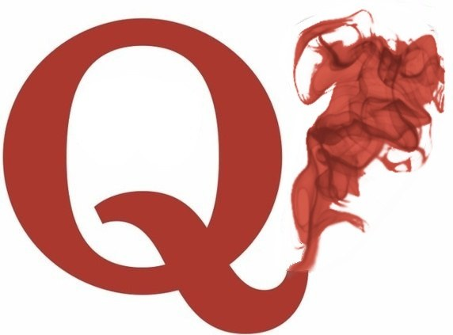



**CHITKARA UNIVERSITY, HIMACHAL PRADESH**

**TABLE OF CONTENT**

1. **Introduction**

* + 1. **Purpose**
    2. **Scope**
    3. **Definition, Acronyms, or Abbreviations**
    4. **References**
    5. **Overview**

1. **General Description**

* + 1. **Product Perspective**
    2. **Product Functions**
    3. **User Characteristics**
    4. **General Constraints**
    5. **Assumptions**

1. **Functional Requirements**

1. **Non-Functional Requirements**

1. **System Architecture**

1. **System Models**

1. **Appendices**

**1. INTRODUCTION**

**1.1 PURPOSE**

He purposes of this document is to give a detailed description of the requirements for the Quora software. It will illustrate the purpose and complete declaration for the development of system. It will also explain system constraints, interface and interactions with other external applications. This document is primarily intended to be proposed to the public and business people and a reference for developing the first version of the system for the development team.

**1.2 SCOPE**

Is an internet enabled electronic platform that facilitates communication for the purposes of advertising and distributing information pertaining to goods and/ or services? You further agree and understand that the software do not endorse, market or promote any of the listings, postings or information, nor do this software at any point in time come into possession of or engage in the distribution of any of the goods and/ or services, you have posted, listed or provided information about on site.

**1.3 DEFINITION**, **ACRONYMS, OR ABBREVIATIONS**

Quora’s mission is to share and grow the world’s knowledge. A vast amount of the knowledge that would be valuable to many people is currently only available to a few — either locked in people’s heads, or only accessible to select groups. We want to connect the people who have knowledge to the people who need it, to bring together people with different perspectives so they can understand each other better, and to empower everyone to share their knowledge for the benefit of the rest of the world.

The heart of Quora is questions — questions that affect the world, questions that explain recent world events, questions that guide important life decisions, and questions that provide insights into why other people think differently. Quora is a place where you can ask questions you care about and get answers that are amazing.

Quora has only one version of each question. It doesn’t have a left-wing version, a right-wing version, a western version, and an eastern version. Quora brings together people from different worlds to answer the same question, in the same place — and to learn from each other. We want Quora to be the place to voice your opinion because Quora is where the debate is happening. We want the Quora answer to be the definitive answer for everybody forever.

**Understand the World and The People In It**

Quora has content you will feel good about having read. Quora helps you understand why the world works the way it does, why people behave the way they do, and what we can all do to make the world better. Quora provides a personalized feed of insightful answers to questions you hadn’t realized you should ask.

Quora’s answers come from people who really understand the issues and have first-hand knowledge. Quora is the place to read Barack Obama on the Iran deal, prisoners on life in prison, scientists on global warming, police officers on how to deter burglars, and TV producers on how their shows are made. Quora is the place to read inspiring people such as Gloria Steinem, Stephen Fry, Hillary Clinton, Glenn Beck, Sheryl Sandberg, Vinod Khosla, and Gillian Anderson directly answering the questions people most wanted them to answer. Quora is where you can read important insights that have never been shared anywhere else, from people you could never reach any other way.

**1.4 REFERENCES**

1. www.template.net
2. www.jqueryui.com
3. www.bootstraptemplate.com
4. www.w3schools.com

**1.5 OVERVIEW**

**Quora** is a question-and-answer website where questions are asked, answered, edited, and organized by its community of users in the form of opinions. Its publisher, Quora Inc., is based in Mountain View, California. The company was founded in June 2009, and the website was made available to the public on June 21, 2010. Users can collaborate by editing questions and suggesting edits to answers that have been submitted by other users. In September 2018, Quora reported hitting 300 million monthly users. Users on Quora are known for writing long, blog post-like answers.

Quora was co-founded by former Facebook employees Adam D'Angelo and Charlie Cheever in June 2009. When asked why they chose the name, Cheever stated, "I associate it with 'quorum' or public congregation. We spent a few hours brainstorming and writing down all the ideas that we could think of. The closest competition that Quora had was 'Quiver' but we eventually settled on Quora."

Quora's user base has been growing quickly since 2010. As of April 2017, Quora has claimed to have 190 million monthly unique visitors, up from 100 million a year earlier.

In June 2011, Quora redesigned the navigation and usability of its website Quora made an official iOS app on September 29, 2011, followed by an Android app on September 5, 2012.

[https://upload.wikimedia.org/wikipedia/commons/thumb/c/ca/Google_Search_popularity_of_Quora.png/220px-Google_Search_popularity_of_Quora.png](https://en.wikipedia.org/wiki/File:Google_Search_popularity_of_Quora.png)

Google Search popularity of Quora over 5 years

In September 2012, co-founder Charlie Cheever stepped down as co-operator of the company, taking an advisory role.

In January 2013, Quora launched a blogging platform allowing users to post non-answer content on their profiles.

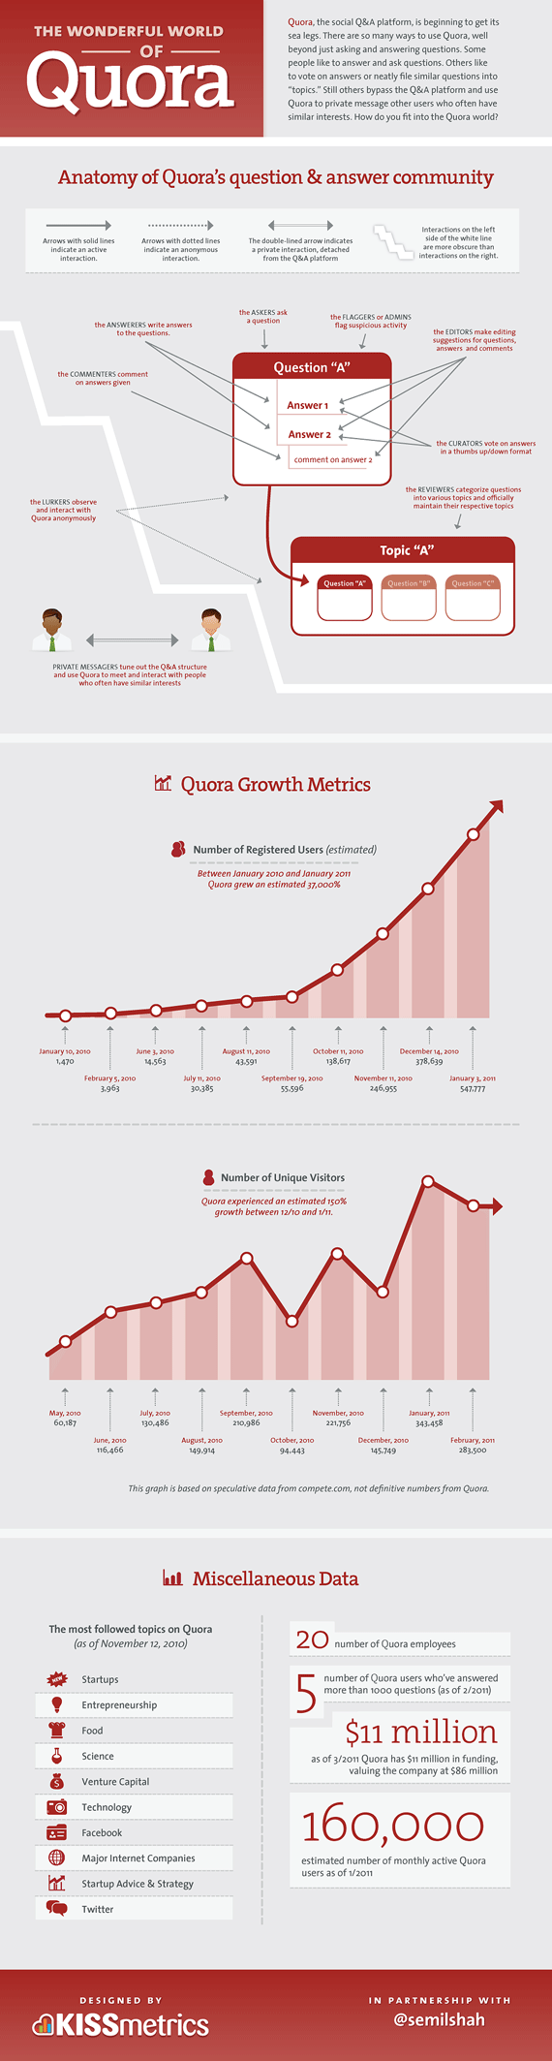

**2. GENERAL DESCRIPTION**

**2.1 PRODUCT PRESPECTIVE**

The Buy Through Quora option is a 5-step process. Firstly, the buyer needs to enter the price that has been agreed upon after discussions with the seller (through Quora Nxt of course). Once the seller accepts the price, a Quora representative will get in touch with the buyer and collect cash payment. Then Quora will deliver the product to the buyer, and after confirmation of delivery the payment is released to the seller. The buyer has the option to return the product within 5 days of delivery and get their money back.

**2.2 PRODUCT FUNCTIONS**

Quora requires users to register with the complete form of their real names rather than an Internet pseudonym (screen name); although verification of names is not required, false names can be reported by the community. This was done with the ostensible intent of adding credibility to answers. Users with a certain amount of activity on the website have the option to write their answers anonymously but not by default. Visitors unwilling to log in or use cookies have had to resort to workarounds to use the site. Users may also log in with their Google or Facebook accounts by using the OpenID protocol. They can upvote or downvote answers and suggest edits to extant answers provided by other users. The Quora community includes some well-known people such as Jimmy Wales, Richard A. Muller, Justin Trudeau, Barack Obama, Hillary Clinton, and the late Adrián Lamo, as well as many current and former professional athletic personalities.

Quora allows users to create user profiles with visible real names, photos, site use statistics, etc., which users can set to private. In August 2012 blogger Ivan Kirigin pointed out that acquaintances and followers could see his activity, including which questions he had looked at. In response, Quora stopped showing question views in feeds later that month. By default, Quora exposes its users' profiles, including their real names, to search engines. Users can disable this feature.

**2.3 USER CHARACTERISTICS**

The following is a list of some of the characteristics you might want to know about each user segment. Not all characteristics are relevant for all types of product — some may only be appropriate for software used at a workplace, for instance.

* Domain-related knowledge and skills (e.g., accounting knowledge for an accounting application)
* General sources of stress or anxiety (e.g., deadlines, performance targets, workplace competition)
* Persistence, patience, confidence, problem-solving ability, curiosity, ability to deal with change, etc.

**2.4 GENERAL CONSTRAINTS**

1. Customer should pay using credit or debit card to place order.
2. System is limited to http/https protocols.
3. Buyer is not allowed to edit any data seller post.

**2.5 ASSUMPTION**

1. Rules and responsibility are already established.

2. Administration is already created.

1. **Functional Requirements**

These are the requirements which are not being asked by customer but the designer will include to make it better software like SECURITY  
PORTABILITY, Maintainability, etc. actually there is no use for customers from this nonfunctional requirement but these are very important for that particular customer from getting hacked by others.

* Second requirement will be a dashboard in which one can check either person want to go to home or search the desired page or logout or sign-out.
* There should be a search engine in which if we search anything the search analysis should be provided.
* There should be a login database so that whenever we save our email id as well as password both are saved and if we try to login again it is provided again.

1. **NON-FUNCTIONAL REQUIREMENTS**

These are the minimum requirements for the system in which one can easily run the software without any technical issues.

One should keep in mind that any technical specs below it will create a minor glitches while opening the designed site.

**Hardware & Software Configuration Hardware Requirement**

✓ Intel Core 2 Duo,2.93 GHz

✓ 2.00 GB RAM and above

✓ 6 Mbps. LAN and above

✓ 500 G.B. Hard disk and above

 **Software Requirement**

✓ Operating System: Microsoft Windows XP or Higher

✓ Front-End: ASP.NET

✓ Web browser: Mozilla Firefox, Google Chrome (Recommended), Internet explorer.

✓ Back-End: SQL Server

1. **SYSTEM ARCHITECTURE**

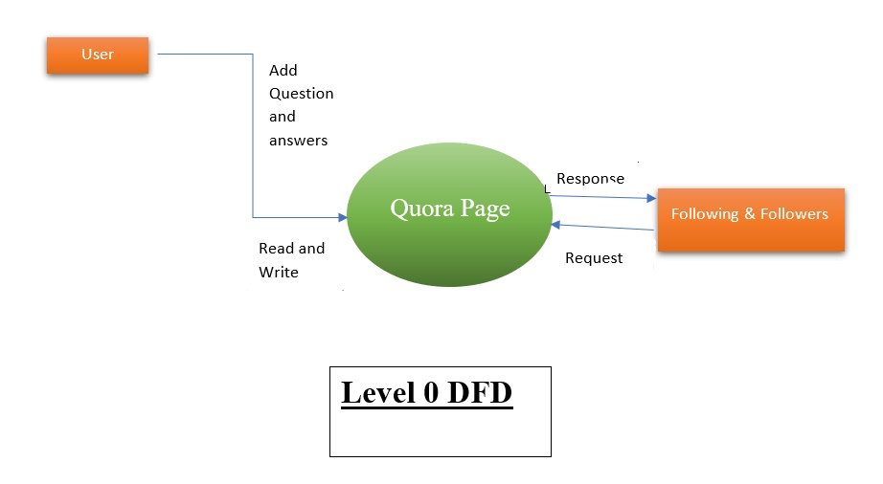

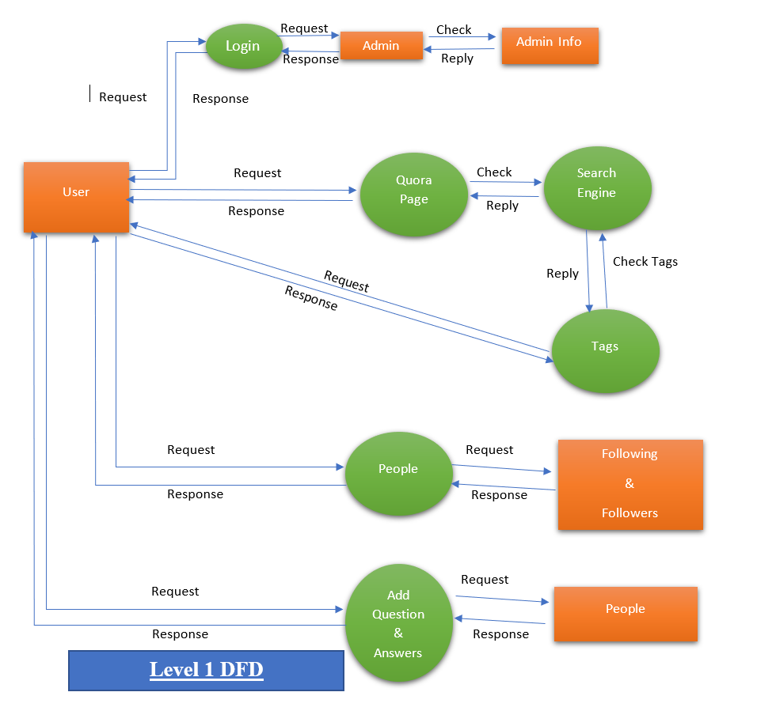

1. **SYSTEM MODELS**

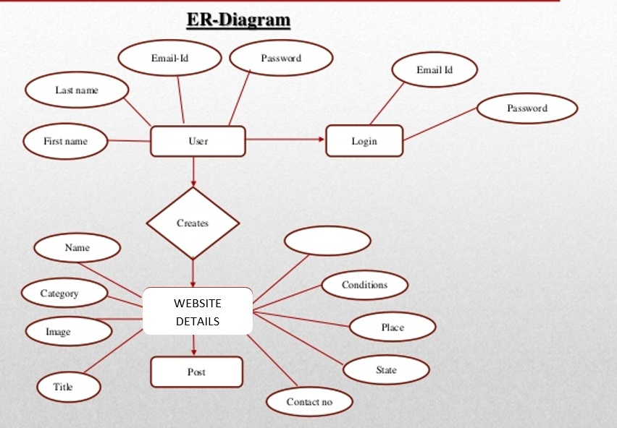

Forums

1. **APPENDICES**

Quora was reviewed extensively by the media in 2010. According to Robert Scoble, Quora succeeded in combining attributes of Twitter and Facebook. Later, in 2011, Scoble criticized Quora for being a "horrid service for blogging" and, although a decent question and answer website, not substantially better than competitors.

In 2014, Quora attracted controversy for using [robots.txt](https://en.wikipedia.org/wiki/Robots.txt) to ask crawlers such as the Internet Archive's Wayback Machine to not index or archive the site. Their stated reason is that the Wayback APIs as of 2016 does not give users a way to censor answers that they may regret previously posting. Critics have raised concerns about the fate of Quora's data if the site ever goes offline and recommended Stack Overflow as an easily archived alternative.

After question details were removed in August 2017, Quora was highly criticized for doing so. According to some users, the removal of question details limited the ability to submit personal questions and other questions requiring question details. According to an official product update announcement, the removal of question details was made to emphasize canonical questions.

As of February 28, 2018, according to Alexa Internet, the United States makes up the largest user base at 37.1%, followed by India at 19.2%, with an overall global site ranking of 93.